University Portfolio Report

Institutional Performance Evaluation Standards

(Standard 1 – 11)

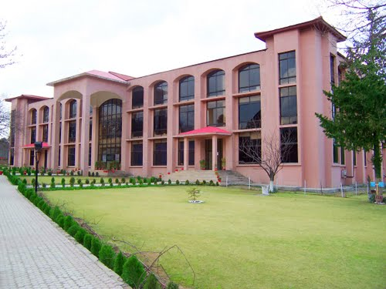

COMSATS University
Islamabad
Abbottabad Campus

Table of contents
0. Standard: UNIVERSITY-WIDE DATA 3
1. Standard: Mission & Objectives 15
1.1. Questions 15
1.2. Supporting Materials on the Table 1 for Standard One: 17
2. Standard: Planning and Evaluation 19
2.1. Questions 19
2.2. Supporting Materials on the Table 2 for Standard Two: 28
3. Standard: Organization and Governance 29
3.1. Questions 29
3.2. Supporting Documents on the Table 3 for Standard Three 33
4. Standard: Integrity 36
4.1. QUESTIONS: 36
4.2. Evidence for Fulfillment of the Standard Four: 38
5. Standard: Faculty 40
5.1. Questions 40
5.2. Supporting Documents on the Table for Standard Five 50
6. Standard: STUDENTS 55
6.1. Questions 55
6.2. Supporting Documents On The Table For Standard: 57
7. Standard: Institutional Resources 58
7.1. Questions 58
8. Standard: Curricula and Academic Programs 63
8.1. Questions: 63
9. Standard: Public Disclosure and Transparency 82
9.1. QUESTIONS 82
9.2. Supporting Documents As Evidence On The Table For Standard Nine: 83
10. Standard: ASSESSMENT & QUALITY ASSURANCE 86
10.1. Questions: 86
10.2. Supporting Documents On The Table For Standard: 94
11. Standard: Student Support Services 94
11.1. Questions 94
11.2. Supporting Documents Required As Evidence For Standard 11: 97

